Software Design Specification
SDS-001
Version 1.0

Project/Department: | XXX
Issue Date: | May 11, 2007
Issue Status: | Initial Draft
Owner: | Hai Nguyen Thi Duyen
Author: | Hai Nguyen Thi Duyen
Location: | XXX Repository
Confidential Class:

Document Reviewer Information
Reviewer Name | Review Attendance (R/S) | Comments
A | R
B | R
C | S
R/S: Required or Suggested participants or functions for the document review meeting.

Document Approver Information
Approver name | Approver Function | Comments
A | R
B | R

Document Control and History
Date | Version | Description | Revised by
Jan 22, 07 | 0.1 | First version | Thuan Tran
Feb 05, 07 | 0.2 | - Break use case diagrams into new sections  - Added a paragraph to the end of section 3.3.3  - Updated the section 3.4.2 to detail the logic of sending notifications. | Thuan Tran
Feb 22, 07 | 0.3 | Update per comments from Customer | Minh Nguyen

Table of content
Document Control and History 2
Table of content 3
About this Document 4
1 Overview 4
2 System Architecture 4
3 Subsystems 5
3.1 Sitemap Editor 5
3.1.1 UseCase Diagrams 5
3.1.2 Overview 5
3.1.3 Interfaces 7
3.1.4 Sequence Diagrams 8
3.1.5 Data Model 9
3.1.6 Risk Analysis 9
3.1.7 Error Handling 9
4 Global Cache 10
5 Exception Management 10
6 Performance and Scalability 10
7 References 10

About this Document
This document is the detailed design of the XXX Sitemap Integration feature which will be integrated to the XXX application.

Overview
XXX Sitmap feature provides functionalities to build a sitemap which helps to improve the presence and visibility of a site content on the Internet to search engines. Providing the sitemap does not mean to increase the overall page ranking for a web site.

System Architecture
The XXX Sitemap Integration feature will be implemented and organized in the three layer model: Presentation Layer, Business Layer and Data Access Layer. The Presentation Layer provides functionalities to interface with users. The Business Layer mainly processes business behaviours. And the Data Access Layer is the only layer to access the Database.
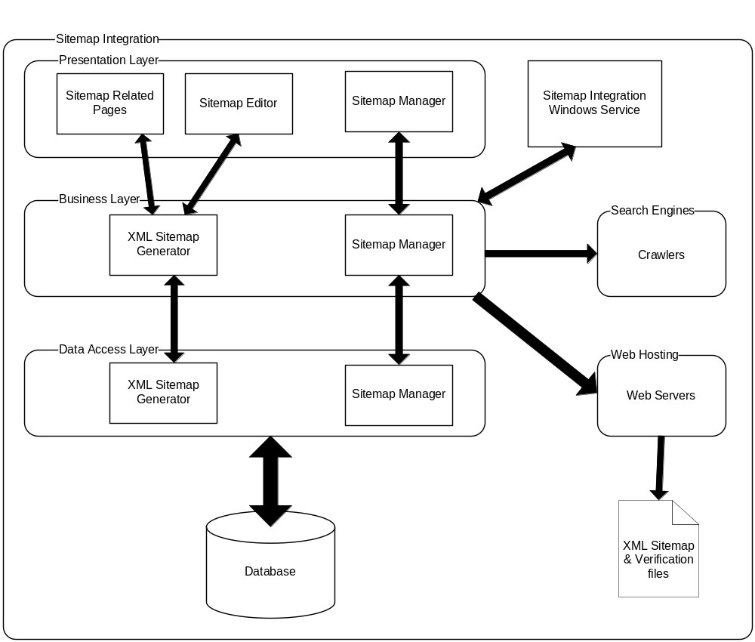

In addition, the system also has the Sitemap Integration Windows Service which submits the sitemap to the web hosting server or notifies search engines the sitemap content changes based on a schedule or on demand.

Subsystems

Sitemap Editor

UseCase Diagrams
The following is the Use Case Diagram for Sitemap Editor:

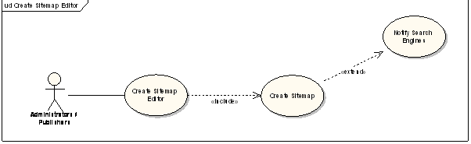

Overview
Sitemap editor is a feature that provides a clickable interface to build and edit the Sitemap. To support this, a new tab named Sitemap Editor is added as a sub tab of the Content Library tab. The Sitemap Editor tab is placed right after the Menu Builder tab. Access to this screen is only allowed to Administrators and Publishers.

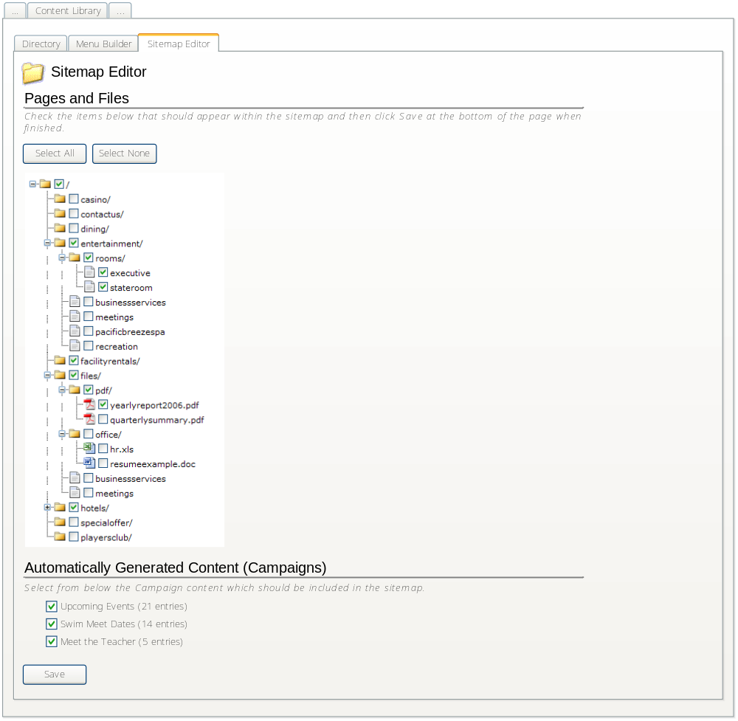
The Page and Files section will be a sitemap tree view. Users will be able to use this tree to edit the content of the Sitemap. The tree view will contain all items in the Page Directory and the “Files” folder from Digital Assets.

The Automatically Generated Content (Campaign) section will contain campaign event types that have been selected to be included in the sitemap. Events in these groups are selectable to be included in the Sitemap.

Interfaces
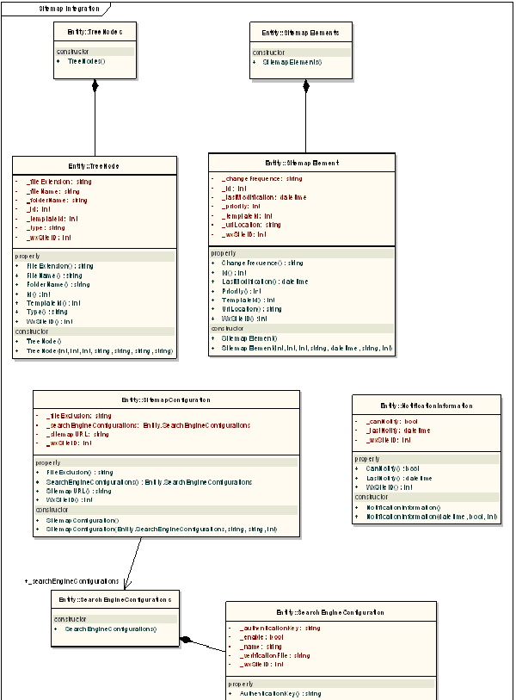
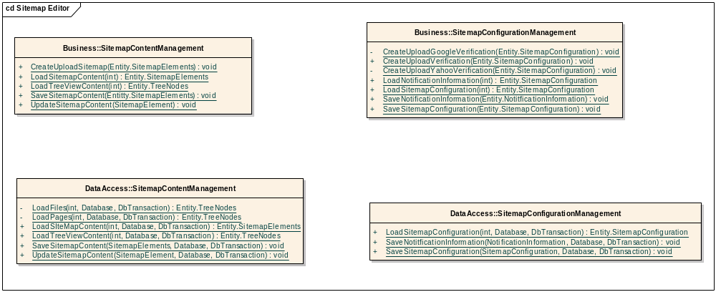

Sequence Diagrams

Sequence diagram for view, edit and save the Sitemap
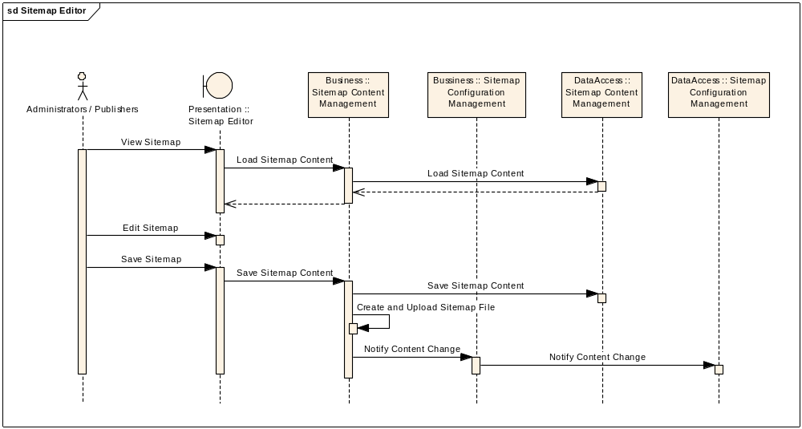

Data Model
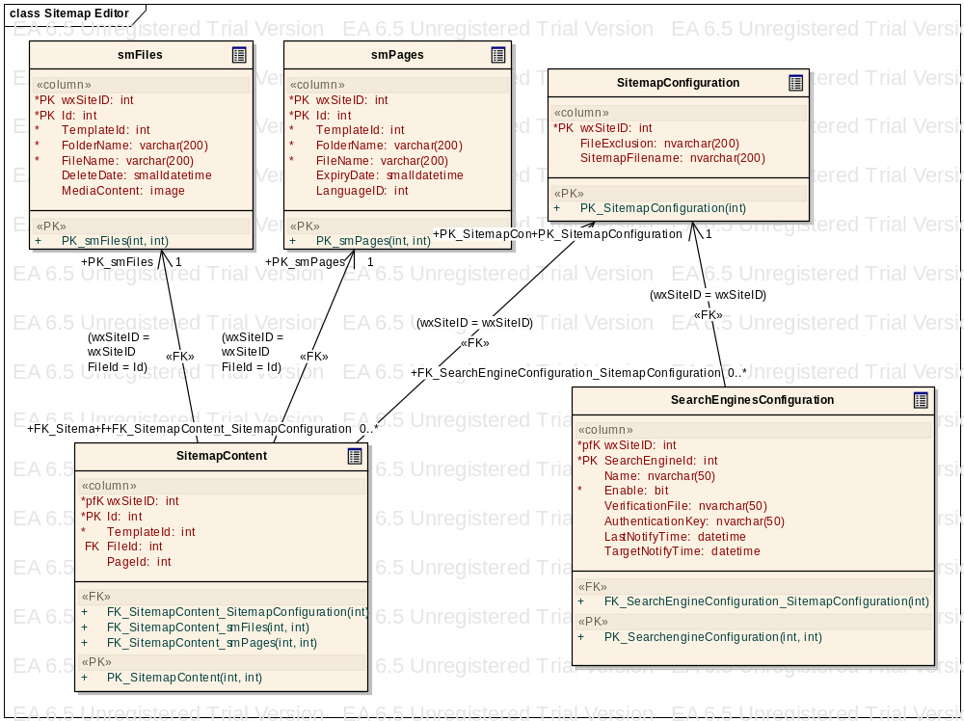

The SitemapContent table contains all information of the Sitemap. It refers to smPages, smFiles tables in order to know how to get a full path of file, page or event.

The SitemapConfiguration table contains the information configured by Sitemap Manager. The FileExclusion field helps to know which files are excluded.

The smPages and smFiles tables have existed in the current database. The schema of these tables won’t be modified.

Risk Analysis
How many nodes the sitemap treeview can support is depended heavily on the treeview control of .Net.

Error Handling
TBD when implement.

# | Situation | Error message
1
2
3
4

Global Cache
To increase the performance and avoid unnecessary accessing database, some entities are loaded into the global cache.

Exception Management
All exceptional cases are handled via Exceptions that are caught by upper layers. Exceptions from data access layer are caught in business layer. For some reasons, the business layer could not catch the exception then it is handled at the presentation layer.

In the presentation layer, if there is any exception then the request will be redirected to an error page to error message.

Performance and Scalability
The current average client size of XXX is well below the 50,000 pages mark, and we are estimating that our files will never be larger that 10MB compressed. That being said, XXX is choosing to forgo the creation and maintenance of sitemap index files (as per the sitemap protocol) which would allow for larger numbers of pages to be referenced (50,000+).

This feature should work normally when the sitemap contains 50,000 pages.

References
# | Documents | version
1 | $/XXX-DEV/SubProjects/XXX Sitemap  Integration/Requirement/XXX Sitemap Integration Spec  (v1).doc | 1.0

